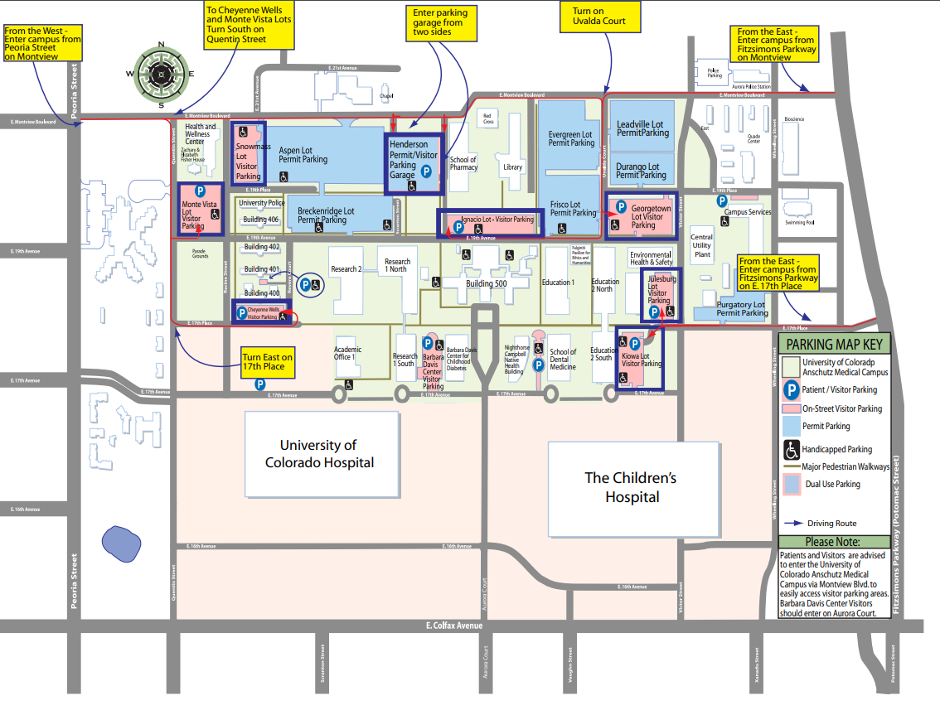

**Driving Instructions From I-225:**

**To Parking Structure From I-225**: West to Aurora Court and North to E. 16th Ave. to Parking Structure for visitors

**To Ignacio Lot from I-225:** West to Fitzsimons Pkwy, North to E. Montview Blvd, South on Uvalda Ct, West on E. 19th Ave.

**I-225**

**MEG**

**LAB**

Ignacio Lot (Pay-to-Park)

FREE UCH VISITOR PARKING LOTS

**Patient Guidelines:**

* Please arrive sleep-deprived (no more than 4 hours sleep)
* No caffeine 8 hours prior to study visit
* Wear NO Metal
* Wear comfortable clothes

When you arrive, wait for MEG Technician at north entrance (back entrance) of the Fitzsimons Building. The MEG technician will escort you to the MEG Lab.

If there is a problem, please call Alex at 903-280-1922.

You may park in the Ignacio Visitor Lot (pay-to-park) or in a UCH Visitor Lot (free)



**University of Colorado Anschutz Medical Campus Map**

**Fitzsimons Building (aka Building 500)**

**13001 E. 17th Pl., Aurora, CO 80045**